
Public Liability Insurance

Claim form

IMPORTANT
- This form should be filled in by the person named as the ‘Insured’ on the policy schedule.

- Form is to be filled in CAPITAL LETTER and signed by the Insured. All asterisked (*) items must be filled to completion

- The issue of this form does not imply admission of liability

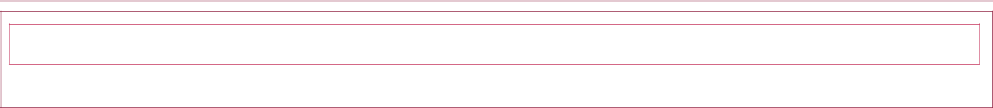

Policy number

Period of Cover From | D | D | M | M | Y | Y | Y | Y | To | D | D | M | M | Y | Y | Y | Y

1. INSURED DETAILS*

Company Name (if applicable)
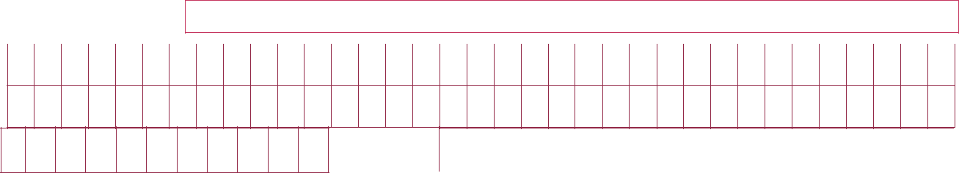

Address

Phone: Email::

We can send you alerts for any update on your claim. Please confirm how you would prefer to receive your alert

 | Email |  |  | SMS |  | Both
 | DETAILS OF LOSS
 | 2. a) Date of Accident |  |  |  |  |  |  | Time | am | pm
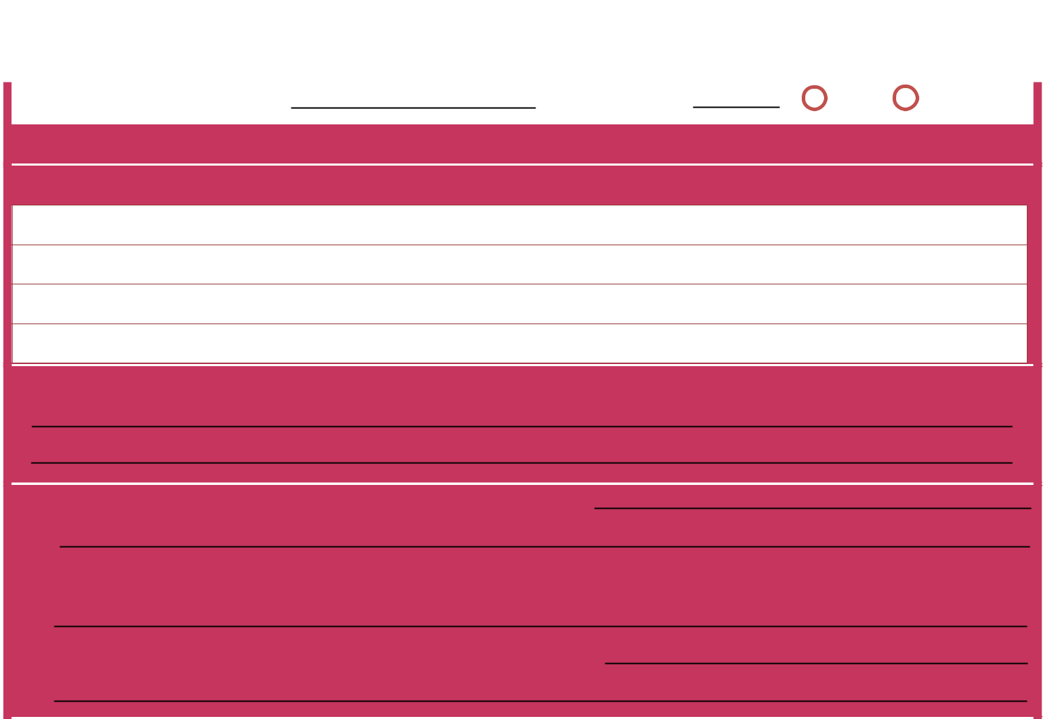
    - Place where accident occured

- Give full details of how accident occured

- Give Name and Addresses of all Witness (Indicated if an employee or independent?

- a) What work were you or your employees engaged to do?

  - Name and Address of Person who caused or who was to blame for the accident

  - Name and Address of this employer, if other than insured
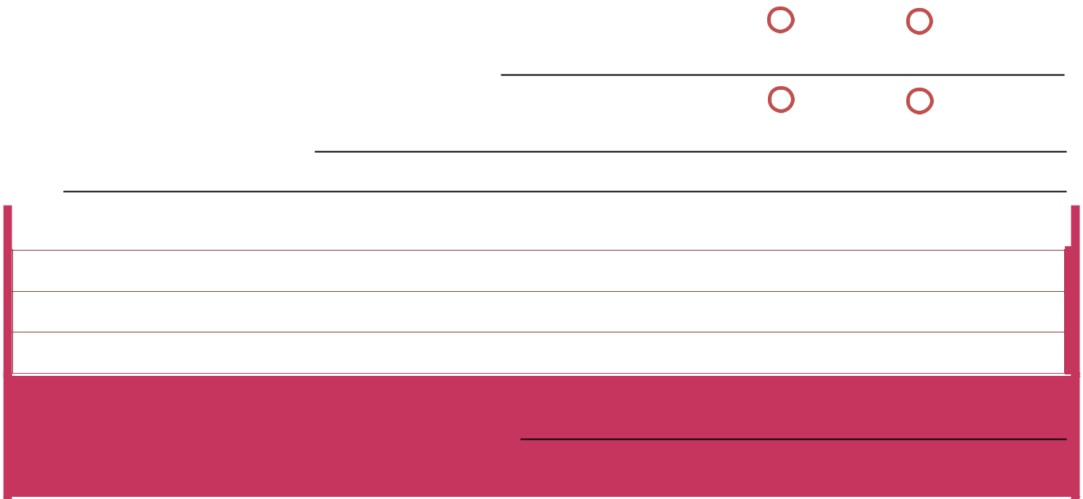 | 6. | a) Were particulars taken by Police? | Yes | No
 |  | b) If YES, give number and station of Officer
 | 7. | a) Do you hold any other policies covering you for this accident? | Yes | No
 |  | b) If YES, give particulars
 | 8. | PARTICULARS OF POSSIBLE CLAIMANT

Name

Address

State nature of injury or damage

9. a) Have you received notice of claims?  Yes No b) If YES, from whom, when and in what form?

If claims is in writing, please forward form to NEM Insurance Plc


DECLARATION
- I/We declare to the best of my/our knowledge and belief that the information given on this form is true in every respect and agree that if I/we have made any false or fraudulent statement, be it suppression or concealment, the policy shall be cancelled and the claim shall be forfeited.

- I/We agree to provide additional information to NEM Insurance, if required.

- I/We agree to submit all required and requested for documents and NEM Insurance shall not be held responsible for any delay in settlement of claim due to non-fulfillment of requirements.



Signature of policyholder
DateD | D | M | M | Y | Y | Y | Y



NEM Insurance Plc. reserves the right to refute any fraudulent claims

CLAIMS PROCEDURE (Please read carefully to understand the claim process)
- NEM Insurance should be notified immediately.
- NEM Insurance may ask for additional documents and /or clarification if any, depending on the requirement of the claim.

For claims status enquiries, you may contact us on 01 448 9570


NEM Insurance
199 Ikorodu Road, Obanikoro, Lagos, Nigeria
Telephone: 01448 9570-2 Website: www.nem-insurance.com

NEM Insurance plc. is regulated by the National Insurance Commission (NAICOM)

